

Retrieval Augmented Generation (RAG)
LLM Lab Extra -
- By Cameron Schaff
Background:
Retrieval Augmented Generation (RAG) is an advanced technique in natural language processing (NLP) that combines the strengths of retrieval-based and generative models to produce more accurate, contextually relevant, and up-to-date responses. It addresses some of the limitations of traditional generative models like GPT by incorporating external knowledge sources during the generation process.

What RAG Does:
1. Knowledge Retrieval: RAG systems first retrieve relevant information from an external knowledge base or document corpus. This can be a database, a set of documents, or any structured or unstructured data source.
2. Contextual Augmentation: During the generation process, the model accesses this retrieved information to augment its understanding of the input prompt. This means that the model doesn't just generate text based on its training data but also incorporates additional, contextually relevant information from the external sources.
3. Response Generation: The augmented context is then used to generate responses that are not only coherent and contextually appropriate but also grounded in the latest or most relevant information available.

How RAG Improves Responses:
- Contextual Relevance: By integrating real-time or near-real-time data, RAG ensures that responses are highly relevant to the current context, reducing the risk of generating outdated or incorrect information.
- Diversity and Freshness: RAG can provide more diverse and up-to-date answers compared to static models trained on fixed datasets.
- Reduced Hallucinations: Since RAG relies on actual data from external sources, it can reduce the occurrence of "hallucinations" (generating facts that are not supported by the available data).
- Customization: RAG allows for fine-tuning the retrieval process to focus on specific domains or topics, making it highly adaptable to various applications.

Other Uses of RAG:
- Customer Service: Providing up-to-date product information, FAQs, and support responses.
- Content Creation: Generating articles, reports, and other written content that incorporates the latest research or data.
- Education: Enhancing learning materials with real-time data and expert insights.
- Healthcare: Delivering patient-specific information and treatment recommendations based on the latest medical research.

Fine Tuning vs. Retrieval Augmented Generation
Fine Tuning:
- Definition: Fine tuning is a process where a pre-trained model is further trained on a specific dataset to improve its performance on a particular task or domain.
- Process: It involves adjusting the model's parameters using labeled data from the target domain, often requiring significant computational resources and time.
- Limitations:
- Data Dependency: Requires a large amount of high-quality labeled data for effective fine-tuning.
- Overfitting: There is a risk of overfitting to the fine-tuning dataset, especially if the target domain has limited data.
- Static Knowledge: The model's knowledge remains static once fine-tuned, meaning it does not incorporate new information from external sources.

Retrieval Augmented Generation (RAG):
- Definition: RAG combines a pre-trained generative model with an external knowledge retrieval mechanism to generate responses.
- Process:
- Knowledge Retrieval: The model retrieves relevant information from an external source during the generation process.
- Contextual Augmentation: The retrieved information is used to enhance the model's understanding and generate more contextually relevant responses.
- Dynamic Updates: RAG can incorporate new or updated information as it becomes available, making it more adaptable to changing contexts.
- Advantages:
- Real-Time Relevance: Provides responses that are always up-to-date and contextually relevant.
- Diverse Knowledge Base: Can leverage a wide range of external sources, enhancing the model's versatility.
- Reduced Overfitting: Since the model does not rely solely on its training data, it is less prone to overfitting.

Key Differences:
- Data Source: Fine tuning relies on the pre-trained model's existing knowledge, while RAG incorporates external knowledge sources dynamically.
- Adaptability: RAG is more adaptable and can incorporate new information as it becomes available, whereas fine-tuning requires retraining with new data.
- Performance: RAG generally provides more contextually relevant and up-to-date responses compared to fine-tuned models, which may struggle with outdated information.
- Resource Intensity: RAG typically requires less computational resources for the retrieval process but may need more data for effective knowledge base construction. Fine-tuning, on the other hand, is resource-intensive but can achieve higher performance with targeted data.
In short
Retrieval Augmented Generation (RAG) offers a powerful approach by integrating external knowledge sources, enhancing contextually relevant and up-to-date responses. This makes it valuable for various NLP applications.
RAG Specific Models:
Making Models RAG-Specific

Retrieval-Augmented Generation (RAG) models are specifically designed to integrate retrieval mechanisms with generative models, enhancing their ability to produce contextually relevant and accurate responses. To make a model RAG-specific, several key components and techniques are employed:

1. Integration of Retrieval Mechanisms
- Knowledge Base Integration: The core of an RAG model is the retrieval mechanism, which fetches relevant information from an external knowledge base (KBB). This KBB can be a database, a set of documents, or even a graph database. The retrieval process involves querying the KBB based on the input prompt to find the most relevant documents or passages.
- Embedding and Vectorization: The retrieved documents are converted into embeddings, which are numerical representations that capture the semantic meaning of the text. These embeddings are then used to match the input prompt with the relevant documents in the KBB.

2. Contextual Augmentation
- Enhanced Context: By incorporating retrieved information, RAG models provide a richer context for the generative process. This context helps the model generate more accurate and relevant responses by grounding its understanding in external data.
- Dynamic Updates: RAG models can be updated with new information from the KBB as it becomes available, ensuring that the model's knowledge remains current and relevant.

3. Generative Process
- Guided Generation: The retrieved information is used to guide the generative process. For example, when generating a summary, the model might use the context from the retrieved documents to craft a more comprehensive and accurate summary.
Benefits of Using RAG Models
1. Improved Accuracy and Relevance
- Contextual Understanding: RAG models leverage external knowledge to provide more accurate and contextually relevant responses. This is particularly useful in scenarios where the model needs to draw on specific, up-to-date information.
- Reduced Hallucinations: By grounding the generative process in external data, RAG models are less likely to produce hallucinations (invented or incorrect information) that can occur with purely generative models.

2. Enhanced Knowledge Coverage
- Broad Knowledge Base: RAG models can access a vast and diverse knowledge base, allowing them to handle a wide range of topics and questions more effectively.
- Customizable Knowledge Sources: The flexibility to integrate different types of KBBs (e.g., databases, documents, graphs) enables the model to be tailored to specific domains or use cases.

3. Scalability and Flexibility
- Scalable Retrieval: RAG models can scale by adding more retrieval mechanisms or expanding the KBB, making them suitable for large-scale applications.
- Domain Adaptability: The modular design of RAG models allows for easy adaptation to new domains or tasks by updating the retrieval and generative components.

4. Cost-Effectiveness
- Reduced Training Costs: RAG models can be trained on pre-existing data rather than requiring extensive training from scratch, reducing computational costs.
- Efficient Use of Resources: By leveraging existing knowledge, RAG models can generate high-quality responses with less computational overhead compared to purely generative models.

5. Ethical and Transparent Responses
- Transparency: The use of external knowledge sources makes the model's decision-making process more transparent, as users can trace back the information used to generate a response.
- Ethical Considerations: RAG models can help mitigate ethical issues related to misinformation by grounding responses in verified data.
Example Workflow for an RAG Model
1. Input Prompt: The user provides a query or question.
2. Retrieval Step:
- Query Embedding: Convert the input prompt into an embedding.
- Similarity Search: Query the KBB to find documents or passages that are most similar to the input.
- Ranking: Rank the retrieved items based on relevance and quality.
3. Contextual Augmentation:
- Embedding Generation: Convert the retrieved document embeddings into a context vector.
- Context Integration: Combine the context vector with the input prompt to create a rich, context-aware representation.
4. Generative Step:
- Prompt Engineering: Craft a prompt that leverages the context vector to guide the generative process.
- Response Generation: Use a generative model (e.g., GPT) to produce a response based on the enriched context.
5. Post-Processing:
- Review and Refine: Optionally, review the generated response for accuracy and relevance.
- Output: Present the final response to the user.
In short -
RAG models advance NLP by integrating retrieval and generative capabilities, offering improved accuracy, knowledge coverage, scalability, cost-effectiveness, and transparency. These benefits make them valuable for applications requiring contextually relevant responses, like customer service and content generation.
Purpose
To enhance a small endpoint AI to have knowledge beyond its training data to allow for accurate and relevant responses without major hallucination to respond to the prompt. And enable weaker devices to achieve powerful accurate responses in a specified area via RAG context.
Lab Instructions
Depending on the Base of the LLM instructions can differ, these instructions will be specifically for the OpenWebUI environment created previously in docker.
Start of instruction
Dataset configuration
- It is important to the success of the output to have a readable and well formatted dataset. From personal testing smaller specific datasets work better as models do not read or use as much when greater context is available. Sometimes less is more.
- The easiest way to format this is to use an available word document or txt file and source the raw text copy from Ctrl-A and paste it into the window.
(Grabbing a document)
Asking Ai to format (Using the copy paste from the document for prep)

Copy the printout.
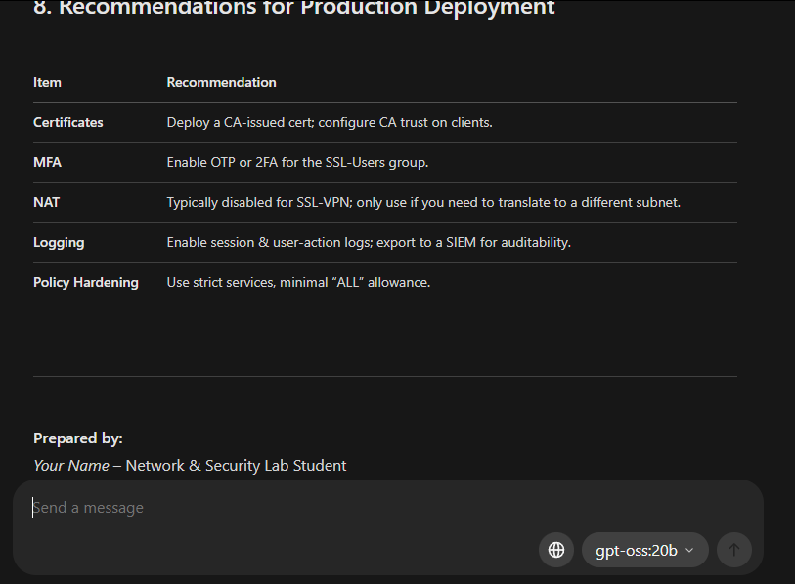
OpenWebUI allows for “Notes” and “Documents” to be included as Rag datasets. These can be managed by group or individually. For this example I will use a note however documents allow for even greater control and some more special editing after the fact.

For notes:

Click on notes to enter a new note page, then paste the Raw Text that the Agent outputted and insert it to this note page.
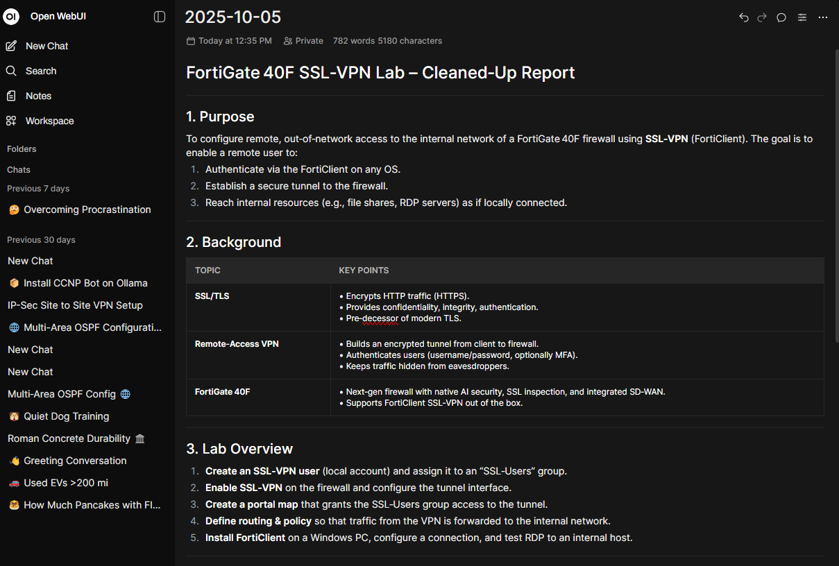
Navigate to the top right corner and find the “chat” icon. (Notes and Documents can be added to datasets which can then be attached to models where it can then choose which document to use but this is the cleanest way to get an LLM to use a document for context)
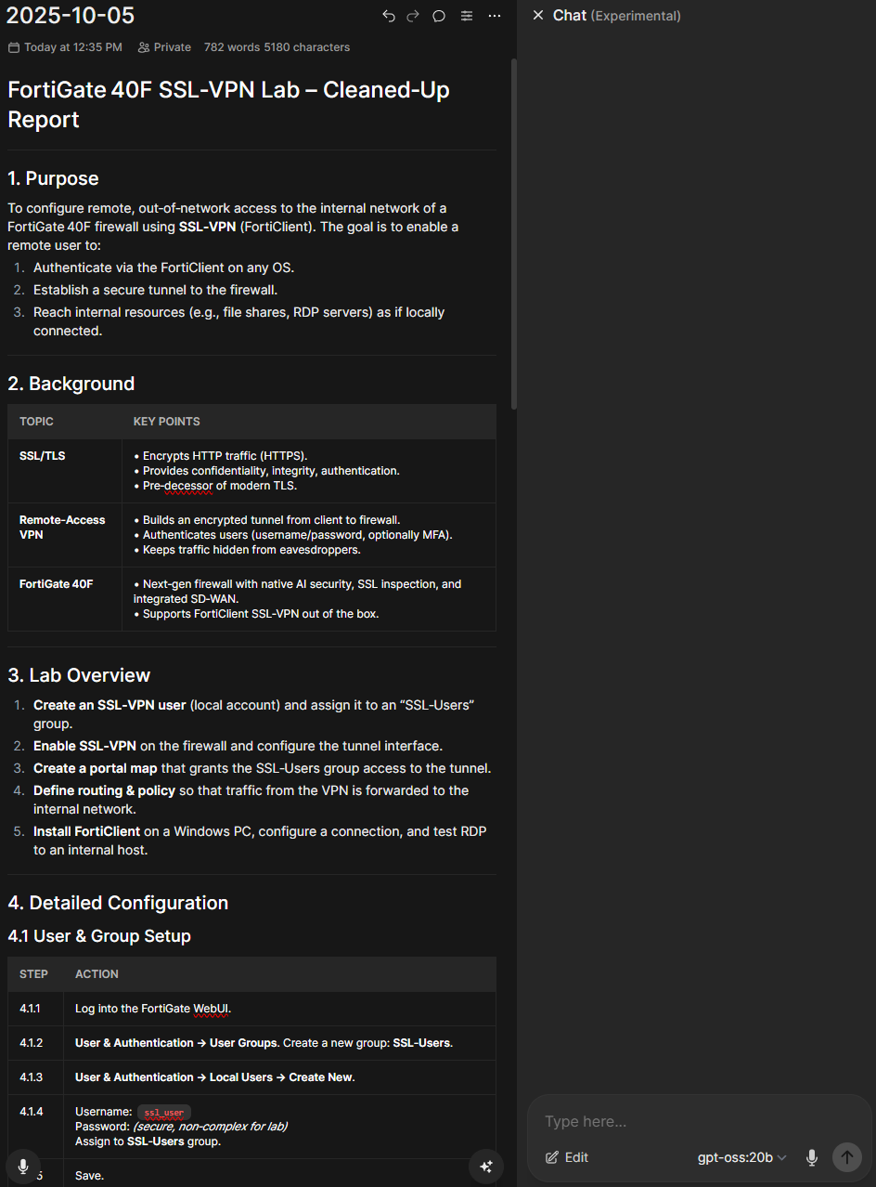
Select your model – For this one I will be using an advanced RAG nemotron-mini:4b Model from nvidia.
(any model is capable of RAG inside of the Ollama Web GUI but performance and accuracy may vary depending on the size and choices of the model)
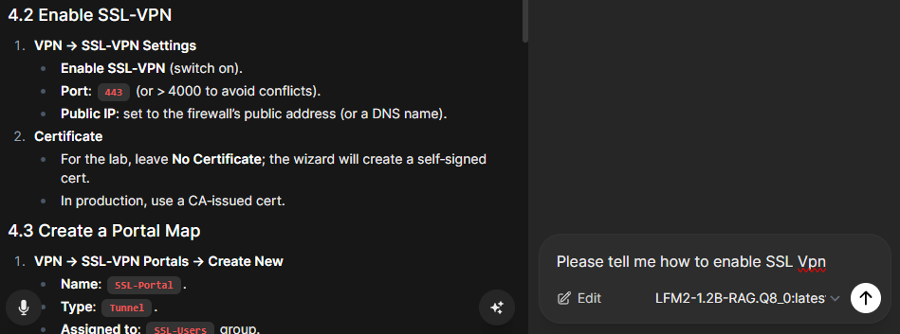
Here is what it should look like
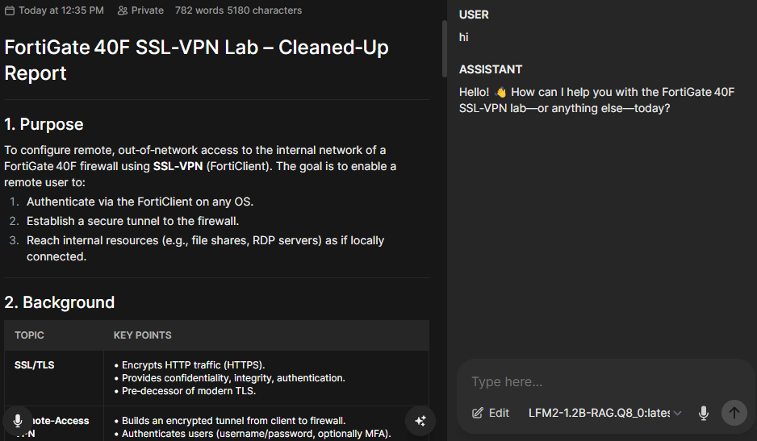
The assistant is versed in the context of the document and is now able to use it as reference when answering questions. This improves accuracy and makes troubleshooting more responsive. Other notes or context can be added and the more info on the page the more the AI will consider.
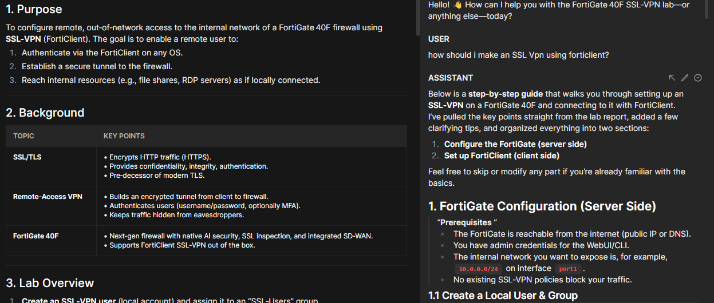
It uses its own knowledge after referencing the document and is capable of answering specific advanced questions improving accuracy and helpfulness giving the information some credibility. In this way the Ai also has access to more recent and relevant information and can be used as a general context or ignored as you could see when I messaged it hi. It dose not inhibit functionality of the Ai in general but is more of a crutch that it can use to be more helpful to yourself.
Problems:
- Some Models do not support the chat feature as it is still in experimental stages and should divert back to injecting it into the model in the model settings page.
Ex –


Then to inject use ->
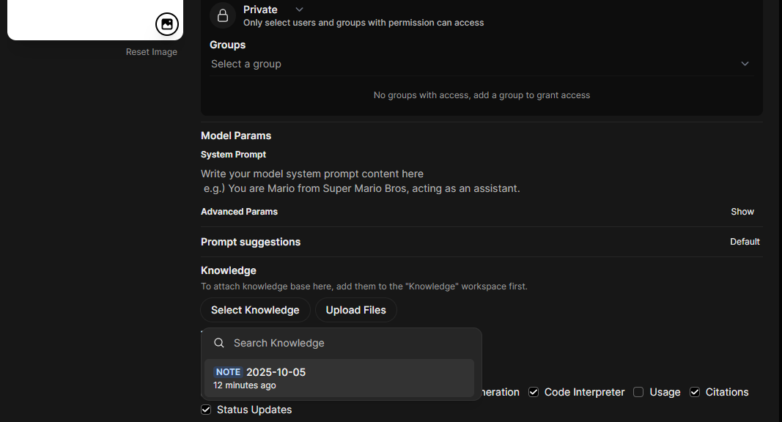
Then Save & Update
This enables RAG responses in the normal chat window when using this Ai model but effects other responses not related to the document and it may start to hallucinate more than without the context. This is because this style forces rag instead of combing the knowledge of the model with the context provided and will probably be resolved in the future as there is not an official fix.
Conclusion
The use of RAG in LLM’s can enhance the user experience and make the tools available more specific to yourself just as much or more as fine tuning LLM’s. This context brings the benefits of specially trained AI without the expensive equipment and time required to train models on large datasets while still providing accurate and specified responses in accordance with the specifications of your ask. It can only give as much as you provide it with. With these tools I hope to enable you to troubleshoot, learn and succeed with whatever task you are hoping to accomplish and appreciate the value of the tools at hand.

